Lesson6 & 7: Quiz

CS544 Enterprise Architecture

1. Based on the following classes with annotations write what the table names, column names and data types will be.  
   Please also answer the questions on the back of the page.

|  |  |
| --- | --- |
| @Entity(name=”People”)  public class Person {  @Id  @GeneratedValue  private int id;  private String firstname;  private String lastname;  @OneToMany(mappedBy=”person”)  private List<Pet> pets  = new ArrayList<Pet>();  @Entity  @SecondaryTable(name=”Birth”)  public class Pet {  @Id  @GeneratedValue  private int id;  private String name;  private String species;  private String gender;  @Column(table=”Birth”)  private Date birthDate;  @ManyToOne  @JoinColumn(name=”owner_id”)  private Person person;  @OneToMany  @JoinColumn(name=”Pet_id”)  private List<Toy> toys  = new ArrayList<Toy>(); | @Entity  public class Toy {  @Id  @GeneratedValue  private int id;  private String description;  private String material;  private String color;  @Entity  public class Ball extends Toy {  private int Size;  @Entity  public class StuffedAnimal   extends Toy {  private String species; |

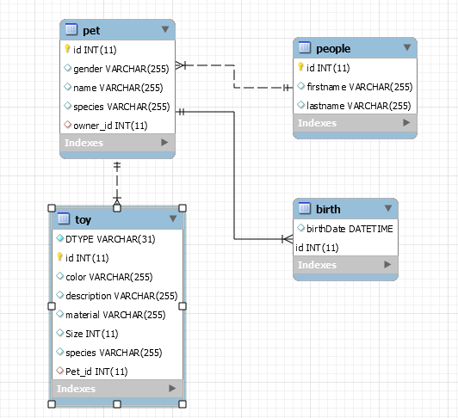

1. Based on the domain from the previous question, write a JPQL query to select all Persons that own a Pet with the name Fido. You can simply write the JPQL string, no need to write Java.

SELECT distinct p from People p join p.pets pt WHERE pt.name = 'Fido'

1. Write a JPQL query to find all Pets owned by John (Person first name) that have a StuffedAnimal (remember StuffedAnimal is a subclass of Toy).

SELECT distinct pt FROM Pet pt JOIN pt.toys t WHERE t.class = StuffedAnimal AND pt.person.firstname = 'John'

1. We have 135 People each with a collection of 20 Books, and we specify Batch Fetching of size 10 on the collection. How many selects are made if we execute the following code:

session = *sessionFactory*.openSession();

tx = session.beginTransaction();

Query query = session.createQuery("from Person");

List<Person> ppl = (List<Person>) query.list();

List<Book> books = **null**;

**for** (Person p : ppl) {

books = p.getBooks();

**for**(Book book : books) {

System.*out*.println(book.getTitle());

}

}

tx.commit();

15